3D Printed N95 Respirator
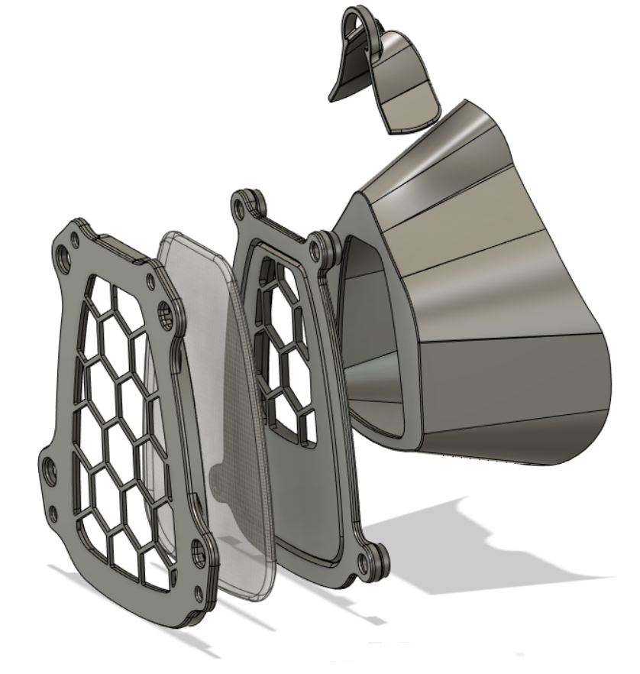
Name: _______________________

3D Printed N95 Respirator
Name: _______________________

3D Printed N95 Respirator
Name: _______________________

3D Printed N95 Respirator
Name: _______________________

